Member Speaker: Dan March w/ LD Supply
EAGA Business Builder
April 14, 2026

• • •
You can easily change the formatting of selected text in the document text by choosing a look for the selected text from the Quick Styles gallery on the Home tab. You can also format text directly by using the other controls on the Home tab. On the Insert tab, the galleries include that are designed to coordinate with the overall look of your document. You can use these galleries to insert tables, headers, footers, lists, cover pages, and other document.
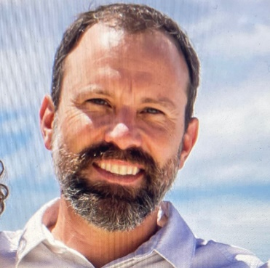
______________________________________________________________________________________
Dan March of LD Supply Company recently delivered a compelling presentation highlighting
both his personal journey and the strategic approach behind his family’s long-standing
business. From his early roots in York, Pennsylvania to an unconventional career pivot that
led him into the facility supply industry, Dan emphasized the value of adaptability, real-
world experience, and relationship-driven business. His story underscored a key theme:
success is rarely linear, and some of the most impactful professional insights come from
stepping outside traditional paths.

At the core of Dan’s message was a practical, results-oriented philosophy for serving
organizations across government, education, and healthcare sectors. Rather than simply
supplying products, LD Supply focuses on identifying inefficiencies—what he described as
“removing the lemons”—to help clients reduce waste, streamline operations, and lower
costs. Through examples like optimizing paper usage, right-sizing consumables, and
simplifying cleaning systems, Dan demonstrated how small operational changes can
produce meaningful financial and environmental impact.

Dan also highlighted the growing importance of proper training, compliance, and innovation
in facility management, particularly in high-stakes environments like healthcare. From
large-scale installations to advanced disinfection technologies, his team’s work reflects a
blend of technical expertise and hands-on problem solving. His closing message to business
leaders was straightforward: most organizations already purchase these essential
products—LD Supply’s value lies in helping them do it smarter, more efficiently, and with
greater long-term impact.

Contact Information:
1503 12th St NW, Albuquerque, NM 87104
Phone: (505) 247-2246
dmarch@ld-supply.com
_________________________________________________________________________________

Announcements:
- We need badge board attendants and speakers for the end of April & May. Please sign up.
- We will continue to host breakfast at Rio Bravo Brewing through the end of May.
- Summer Bash- July 11, 2026
- Golf Tournament: Golfers, we will host this year’s golf tournament on May 29 at Santa Ana Golf Course. Please add it to your calendar. Sign-up sheets will be available on April 14th. Members are free, Guest fee $85/ player, hole sponsorships are available for $100/ hole. All sponsorship money goes towards prizes, long drive, closest to the pin, winning team and skins. 2pm shotgun start. Arrive at 1pm.



New Member Applicant(s)
No new announcements

If you have an objection with any of the above candidates, or if you have information about any of these candidates that should be considered during the review process, please contact our Membership Committee Chairman John Menicucci or Mario Hernandez as soon as possible.
Open Categories (not a full list, rather some ideas)
- Florist
- Orthodontics
- Flooring-residential
- Flooring- commercial
- Auto Glass
- Business Furniture
- Business Broker
- Sporting Goods
- Pediatrist
- Spa
- Limousine Service
- Dermatologist
- Menswear Shop
- Shoe Store
- Barber Shop/ Hairsyle

Badge Board Greeters Schedule

April 21- John Woods w/ Phocus Real Estate
April 28- Lance Darnell w/ Darnell Cable & Fasteners
May 5- Trey Finley w/ New York Life
May 12- Open

Speaker Schedule:
April 21- Mike “Red” Black w/ Big Red Fences
April 28- Steve Douglas w/ The Printing Guy
May 5- Darryl Moreland w/ DLM Collision
May 12- Open
May 19- Trey Finley w/ New York Life

Contact Information for Executive Director: Mario Hernandez
Phone: 505-239-0259 email: eagaed@gmail.com
Postal mail: 8100 Wyoming Blvd, NE Ste M4 #345, Albuquerque, NM 87113
